Web design Case Study
ITC 501
August 2018 |  | Determine client requirements and carry out responsive design of user experience
Report prepared for
Shannon Thomson

Compiled by
Ralph Montefalcon

Contents:

- Web site Purpose
- Target Audience
- Requirements
- Website Pages
- Site Map
- Stakeholders Analysis
- Business Process flow charts
- Home Page Design
- References
- Website Purpose
The purpose of the web site is to allow people to find out about the tours and to enquire or make a booking through the website. Having the tours categorized will help people find their way around the website easily, so that they don’t have to think hard when they want to find something. Lastly gaining customers while also keeping the ones you have are a key thing for the development of this website.

- Target Audience
The target audience of the website will be ages 16 – 50. Backpackers and family are the focus for the website and adventurous individuals.

- Requirements
  - Need to be able to book through the website
  - Staff members can update the website whenever they need to.
  - Promotes the tours and activities in the site.
  - Tour guides should be able to update the blog on the website while they are on activities.
  - A responsive design that can adapt to whatever platform tries to access it
  - Information about the tours prices, names and details.

- Pages
Home Page – Highlighting the popular tours and the place.
About us – Information about our staff and introduction to our business. Also has the history of the business, including some awards and accolades won over the years.
Tours –More information about the tours like where it takes place, what time of the day, when it finishes and also recommended things to bring.
Bookings – Where you choose the tour or activity you want and make the booking for it.
Login/Signup – if you’ve registered for the website or wanting to this is where to go.

- Site Map
Home

Tours
Bookings
About us
Login/Signup
Staff
Tours
Hiking
Snowboarding
Give info
History
Buyer Info
Accolades
Mountain biking
Payment

- Stakeholders Analysis
Group | Power/Interest | Engagement | Analysis
Owner | High/High | High | Wants this website to follow the requirements laid out at the start and hopefully improve by them.
Staff | Low/High | High | Has an idea of the project and wants to test it and see if hopefully it can make their life easier inside or outside the office.
Tourist/  Customers | Low/High | Unaware | Unaware of the project but needed to be involved quickly and get their input on the website.

- Business Flow Charts
Finding a specific Tour
Can’t find a Specific Tour
On the Tours page?
NO
Go to Tours Page.

YES
Tour Unavailable? Or fully booked
Contact staff
NO

YES
Choose another Tour

Booking a Tour
Book a Tour
Have a tour in mind?
NO
Choose a Tour

YES
Want a discount and deals in the future?
NO
Pay for the Tour

YES
Sign up

Cancelling a Booking
Cancelling a Booking

3 days’ notice given
NO
No Refund

YES
Covered by insurance?
NO
No Refund

YES
Refunded

Registering on the Website
Log in
Are you registered?
NO
Click register
And follow instructions

YES
Enter Email and password

- Home Page
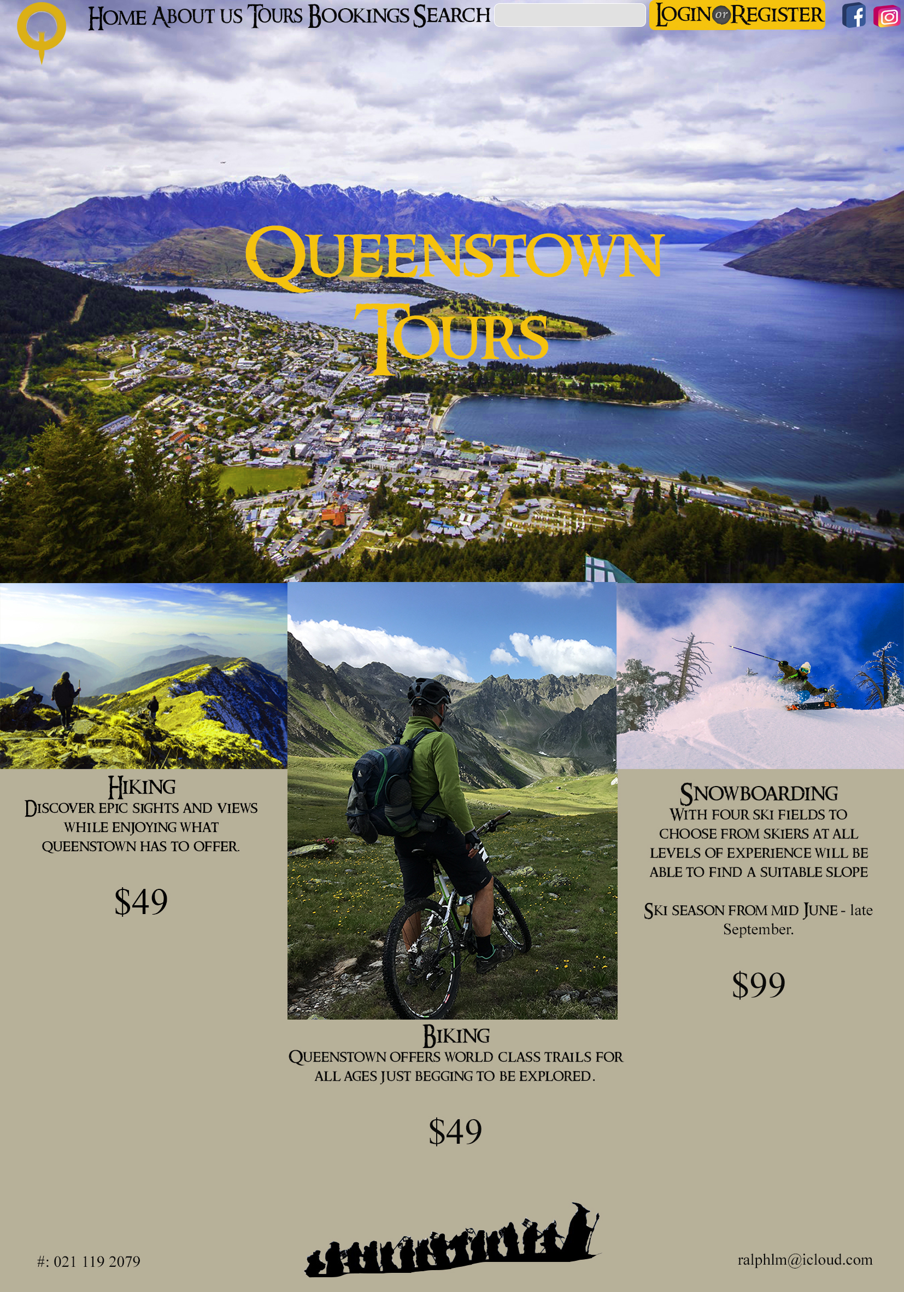

- References
https://reelthinking.wordpress.com/2012/12/14/the-hobbit-an-unexpected-journey/the-hobbit-550x281/

https://dribbble.com/shots/597224-Login-or-Register-Button

https://www.iconfinder.com/iconsets/social-media-2199

https://www.dafont.com/search.php?q=Ring+Bearer

